Jalon 33 - HQMAILSRV DHCP Failover

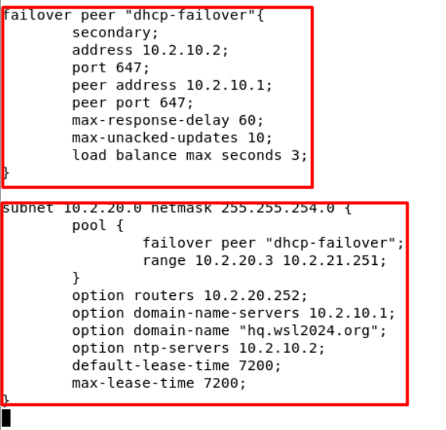

Configuration du DHCP FailOver afin de gérer la distribution DHCP